Active Ageing – What’s your Innovation to help!

**\*\*Just an FYI doc, This is not the report but the background work mainly brainstorming and activities tracking to work on this project as a team.**

Contents

Objective 2

Timeline 2

Define your design challenge for introducing interventions to promote active ageing – Brainstorming 2

Problem Statement - User Persona 3

Desired Interview Format 3

References 4

# Objective

This document acts as the basis for brainstorming and timelines required to finish the various tasks assigned for this assignment work.

# Timeline

|  |  |  |  |
| --- | --- | --- | --- |
| **Phase** | Task | Completion Date | Status |
| 1 | Finalize problem statement | 12/2/2017 | Done |
| 1 | Design interview Questions | 13/2/2017 | Done |
| 1 | Read about interview strategy from lecture notes and conduct interviews for at least 5 each | 15/2/2017 | Done |
| 1 | Meetup to Finalize Survey Questions | 16/2/2017 | Done |
| 2 | Conduct Surveys  Sample size 55-65. At least 50 people convenience sampling  Ideal sample size as per Singapore population (250k) - 358 | 25/2/2017 |  |
| 3 | Analyze survey results and develop prototype | 2nd March | Done |
| 3 | Finalize the prototype and rehearse presentation | 3rd March | Done |

# Define your design challenge for introducing interventions to promote active ageing – Brainstorming

I want to design a monetary generation platform

Muni – Removing the Technology Barrier. What’s stopping them to venture new things and start earning money

Blake – Job opportunities for those who have retired from job and don’t have enough money.

Pradeep – Solve their health issues through fitness management

Min – Art and cultural Learning Opportunities like singing and dancing.

China has these classes which seniors can take in their spare time.

They can make social circle same interest, Healthy & Happy Mind, Community

# Problem Statement - User Persona

**XYZ** is 55-65 years old and he is an internet user. He spends quality time on social networking groups. We want to interview him, what is stopping him from making money through technology.

# Desired Interview Format

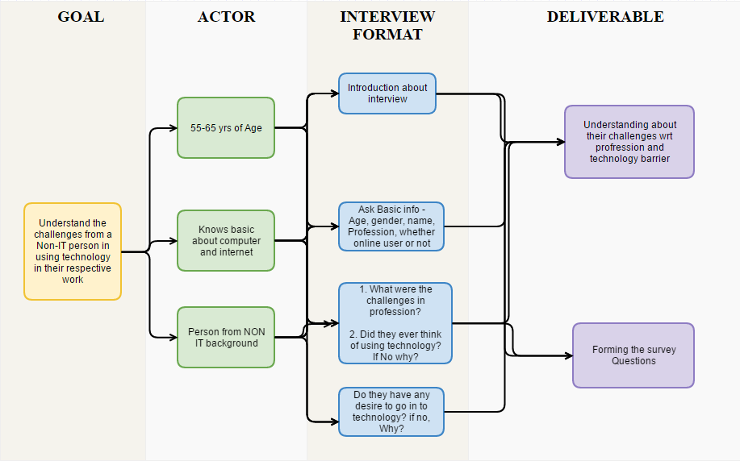

**Sample 1 -Notes**

1. Age 55
2. Housewife
3. Skills – Cooking, Interior design
4. Social network usage – Facebook usage 15-20 mins
5. In Gurgaon, most of the time in household activities, travelling and
6. Health conscious, Yoga, meditation, sports, trekking, reading,
7. Difficult to handle the app
8. Fear of payment
9. Technology barrier
   1. Initial learning
   2. Interests towards sports

**Sample 2 - Notes**

1. Male – 63 years old. Public Sector employee
2. Report creation in software for food analysis
3. Corruption was there. If there was a review process on software, we could have don’t it faster
4. Analysis of US/Canada would have been available
5. Quality of work would have improved.
6. There was no learning available so had to develop a method to do it manually
7. Facebook how much time do you use – Whatsapp, facebook. Google.
8. Now if we have to transfer money online then we are scared of mistakes
9. Learning is slow
10. For financial independence. If must have need to be done.
11. If there is any intuitive solution, I am open to learn

# References

* <http://www.who.int/ageing/active_ageing/en/>
* <https://www.pa.gov.sg/Our_Programmes/Active_Ageing>
* <https://www.moh.gov.sg/content/moh_web/home/pressRoom/pressRoomItemRelease/2015/-3billion-action-plan-to-enable-singaporeans-to-age-successfully.html>
* <https://www.moh.gov.sg/content/moh_web/home/pressRoom/pressRoomItemRelease/2015/-3billion-action-plan-to-enable-singaporeans-to-age-successfully.html>
* <http://lkyspp.nus.edu.sg/ips/wp-content/uploads/sites/2/2014/10/wp22_1510151.pdf>
* <http://ec.europa.eu/public_opinion/archives/ebs/ebs_378_en.pdf>
* <http://www.age-platform.eu/images/stories/Publications/AAI_2014_Report.pdf>